Analysis of the 2024 US Election Shows Continued Inexplicable Twenty-Year Pattern of Republican Favoring “Red-Shift” of Official Vote Count (OVC) Relative to Unadjusted Exit Polls (UEP) in General Presidential Elections
UEP Analysis Suggests that Trump Won the Election but by Fewer Votes, and Did Not Win the National Popular Vote
(Submitted for publication to the Columbus Free Press)

September 10, 2026
By Ron Baiman and Peter Peckarsky
For many years, we and others have analyzed “Unadjusted Exit Polls” (UEP) for U.S. elections. These are exit polls derived by asking voters who have already voted who they supported. The UEP results for a state are the exit poll results reported by the journalistic organizations sponsoring the exit poll when the state’s polls close. These UEPs differ from the “Adjusted Exit Polls” (AEPs) widely reported in the US, which are adjusted to match official vote outcomes hours after the polls close. This universal US practice of conflating UEPs with AEPs is not generally replicated elsewhere. This may be because UEPs reported before official results are tallied have been highly reliable predictors of official election results worldwide, but, for some reason, not in the US since 2004.
To the contrary, analyses of past US General Federal Elections from 2004, 2008 and 2012, 2016, 2020, and now 2024, have shown a consistent “red shift” pattern whereby the Official Vote Count (OVC) falls short of UEP results for Democratic candidates, and exceeds UEP results for Republican candidates, by a statistically significant margin. This pattern is consistent across individual election cycles and cannot be explained statistically by random error or deficiencies in exit polling.
Regarding the last two Presidential elections, our analysis indicates that Biden won the 2020 Presidential election and Trump won the 2024 Presidential election based on both OVC and UEP results. However, the UEP for the 2020 Presidential election suggests Biden may have won by a larger margin than the 2020 OVC recorded, and the UEP for the 2024 Presidential election suggests Trump may have won by a smaller margin than the 2024 OVC recorded and lost the national popular vote.
UEP Analysis of the 2024 Presidential Election
Our UEP analysis of the 2024 US Presidential race is based, as usual, on a comparison of official vote counts with UEP Screenshots captured at the close of polling and sample sizes published by mainstream media outlets. The exit polls also include surveys of voters who cast absentee or mail-in ballots.
Though "red shift" is technically the positive difference between the UEP and OVC margins for the Democratic candidate: Red Shift = (UEP_{D} - UEP_{R}) - (OVC_{D} - OVC_{R}), it is difficult to analyze statistically as candidate voting shares are not independent of each other. In a two-way race, vote shares would be exact complements and "red shift" would be exactly twice the size of each candidate's OVC-versus-UEP deviation. With third-party candidates in the race, the vote-share relationship between the two major-party candidates will not be an exact complement. However, as third-party candidate shares are usually very small, this will still be approximately true. Standard statistical analysis of the difference of two independent proportions is therefore not applicable.
To address this problem, we perform separate single-population hypothesis tests for each major candidate's OVC-versus-UEP vote share by state. Each analysis is then a single-state analysis of UEP-OVC vote-share deviations for the Democratic and Republican candidates in the states where exit polling has been conducted.
Statistical inference is based on using sample statistics to estimate population parameters by knowing the “Sampling Distribution”, or the likelihoods of different sample statistic estimates, for (generally) unknown population parameters. In this case, the UEP is a sample estimate of a state OVC, based on a mathematically derived UEP sampling distribution of state vote-share samples. Standard statistical inference shows that for random samples, the sampling distribution of sample vote shares will be a Normal Probability Distribution, often referred to as a “Bell Curve,” centered around the candidate’s unknown “true” state vote share ‘p’, with a width (dispersion) or “Standard Deviation’ (SD) equal to the square root of p(1-p)/n, for samples with ‘n’ respondents.
For our estimates, as is standard practice when the value of the “true” ‘p’ is unknown (for example, unadjusted exit-polling), we estimate that ‘p’=UEP and assume that this is the center point of the sampling distribution of sample vote shares. The area under the y-values over the X-values less than Harris’s OVC, or the area over the “left tail” of the Harris-UEP centered bell curve for Table 1, then gives the probability of a Harris OVC value that is this small, or smaller, given the Harris-UEP. Similarly, the area under the y-values over the X-values larger than Trump’s OVC, or the area over the “right tail” of the Trump-UEP centered bell curve for Table 2, then gives the probability of a Trump OVC value that is this large, or larger, given the Trump-UEP.
The only adjustment to the standard “single population hypothesis testing for a proportion” used in this case is the use of an “Adjusted Standard Deviation” (ASD) with a 30% "clustered sampling" increase, so ASD = (1+0.3)SD. This is standard exit-polling practice that attempts to account for the fact that, although exit poll samples are approximately random samples of voters within precincts, voter responses are geographically clustered because they come from a select number of precincts chosen by pollsters to represent the state after weighting.,
Table 1, column 3 (below) displays Official Vote Count (OVC) shares for Harris in the 2024 US Presidential election in competitive states in which exit polling was conducted. Column 2 of Table 1 displays Unadjusted Exit Poll (UEP) shares for Harris in these states in the 2024 election. Column 9 shows UEP-OVC differences in percentage terms. Note that UEP-OVC for Harris is positive in all states except for FL, GA, and NV. This indicates a “red shift” from UEP to OVC that is unfavorable to Harris in all but these three states. Column 12 measures these UEP-OVC discrepancies in terms of statistically meaningful standard deviations, enlarged by 30% to account for a possible non-random exit poll response “clustering factor,” as discussed above. Column 13 shows that the positive discrepancies for OH and the US national popular vote share are statistically significant at the 5% level. Column 12 shows that none of the statistical discrepancies in Table 1 are significant at the 1% level.
For example, Column 12 of Table 1 shows that for Harris in OH, the OVC vote share of 43.9% (Column 3) is 2.07 (Column 12) adjusted Standard Deviations (SDs) less than the UEP vote share of 45.8% (Column 2), where the adjusted SD of 0.9% (Column 11) is 30% larger than the unadjusted SD for a Normal Probability Distribution of 0.72% (Column 10). In other words: 2.07= (45.8 - 43.9)/0.9 (where these numbers are rounded). Column 13 shows that the probability that the OVC would be 2.07 standard deviations below the UEP, for a Normal Distribution with an adjusted SD of 0.9% and UEP mean of 45.8%, is 1.9%, or has less than a 1 in 51.6 (Column 14) chance of occurring, as 100/1.9 =52.6 (again with all numbers rounded). The probability that the OVC is this much smaller than the UEP, for an ideal (clustered) random sample of OH voters’ votes in this election, is less than 2.5%, or roughly 1 in 40 (100/2.5 = 40). This is considered to be statistically significant, or highly improbable, at the 5% level (Column 18), as this “one-tail” probability of less than 2.5% that Harris’ Ohio OVC share would be less than her UEP share is equivalent to a “two-tail” probability of 5% that Harris’ OVC vote share would be less than or greater than her UEP vote share.
Table 1: Harris Almost All Unfavorable Battleground State Official Vote Count (OVC) Deviations from Unadjusted Exit Polls (UEP) in 2024 US Presidential Election
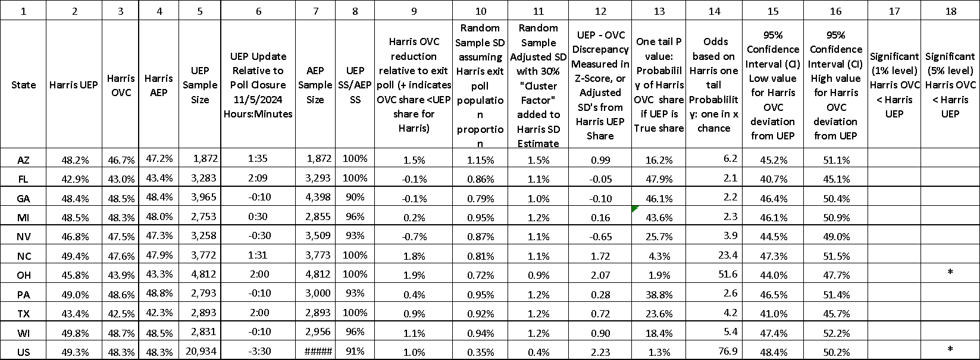
Table 1 thus suggests that for Ohio and the National popular vote, there is less than a 5% chance that the OVC vote share for Harris could be as small as it is if the UEP is accurate. If the OVC had been equal to the UEP in Ohio, Trump would still have won the state but by a smaller margin (see Table 2 and discussion after Table 2 below). However, in the national popular vote, UEP Harris receives roughly one million more votes than Trump, whereas in the OVC results, Trump receives about two million more votes than Harris.
Table 1, columns 3 and 4, respectively, display the OVC and final Adjusted Exit Poll (AEP) values for the 2024 election, and columns 5 and 7 display their respective polling sample sizes by state. Column 6 shows how long before poll closing the UEP used in this analysis was updated; negative values indicate it was updated after poll closing. Thus, 1:35 for AZ indicates that the UEP used in this analysis for AZ was last updated 1 hour and 35 minutes before polls closed, and -0:10 for GA indicates that the UEP used in this analysis for GA was last updated 10 minutes after polls closed. As shown in column 8, all UEP results were reported with 90% or more of the final exit polling sample collected, and in 5 of the 11 cases (or rows), after 100% of the final exit polling sample was collected. As shown in Table 1, columns 2 and 4, the UEP differs from the AEP in all cases except for GA, where the AEP equals the UEP and both are just 0.1% below the OVC.
Columns 2 and 4 show that, in Table 1, the UEP is greater than the OVC in all but three cases: in FL and GA, where the UEP was a marginal 0.1% below the OVC; and in NV, where the UEP was a larger but still statistically insignificant 0.7% below the OVC. Columns 2, 3, and 4 also show that the AEP is closer to the OVC than the UEP, in all cases except WI, where AEP-OVC=-0.6 and AEP-UEP=-0.2. Note that AEP generally does not exactly match the OVC, probably because of rounding errors and attempts to make final exit polls as close as possible to the OVC across all demographic categories, not just the “Gender” category from which the UEP and AEP are calculated in this analysis.
Table 2 shows the likelihood of the Official Vote Count (OVC) given the UEP, for Trump in 2024 in competitive states where exit polling was conducted. Column 2 of Table 2 below displays Unadjusted Exit Poll (UEP) shares by state for Trump in the 2024 election. Column 3 does the same for final Official Vote Count (OVC) shares. Column 9 displays UEP-OVC in percentage terms. This is negative in all cases, indicating a consistent “red shift” pattern favorable to Trump, with OVC exceeding UEP in every state and in the national popular vote. As shown in Table 1, column 12 reports these UEP-OVC discrepancies as statistically meaningful standard deviations, conservatively increased by 30%. Column 13 shows that these discrepancies are statistically significant at the 1% level in OH (one-tailed p-value < 0.5%) and at the 5% level for the US national popular vote share (one-tailed p-value < 2.5%), as shown in columns 17 and 18. Columns 2, 4, and 9 of Table 2 also show that the UEP is less than the OVC and the AEP in every state, except WI, and for the US popular vote. The AEP is equal to or closer to the OVC than the UEP in every case except WI, where it is 0.2% smaller (likely a rounding error – more on WI in the conclusion below).
Table 2: Trump All Favorable Battleground State Official Vote Count (OVC) Deviations from Unadjusted Exit Polls (UEP) in 2024 US Presidential Election
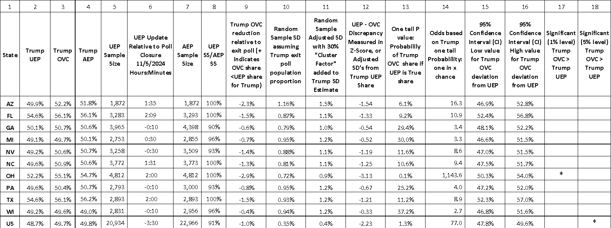
In other words, as displayed in Table 2, column 17 for Ohio, and in column 18 for the national popular vote, there is less than a 1% and 5% (two-tail) chance, respectively, that the OVC vote share for Trump could be as large as it is if the UEP is assumed to be accurate. But as noted above, even if the OVC had been equal to the UEP in OH, the UEP results suggest that Trump would still have won, but by a smaller margin.
But this is not the case for the popular vote, as the sum of statistically significant at the 5% level UEP-OVC discrepancies in Tables 1 and 2 indicates that, based on the UEP, Harris received roughly one million more votes than Trump, compared to the OVC, where Trump received about two million more votes than Harris.
To clarify, from Columns 2 and 3 in Tables 1 and 2, in OH, going from UEP to OVC, Harris lost 1.9%, and Trump gained 2.9%; and in the national popular vote, going from UEP to OVC, Harris lost 1%, and Trump gained 1%, and these were all statistically significant discrepancies.
Similarly, the sum of the WI UEP-OVC discrepancies indicates that, based on the UEP, Harris received more votes than Trump in WI. But the UEP-OVC WI discrepancies of 1.1% against Harris in Table 1, and -0.4% for Trump in Table 2, are both statistically insignificant.
Conclusion
Mainstream commentators have for many years claimed that this consistent “red shift” of smaller OVC than UEP shares for Democrats and larger OVC than UEP shares for Republicans is a result of “reluctant” Republican exit poll response, but the evidence does not support this. In 2004, this “Reluctant Bush Responder” hypothesis was disproven using the exit pollsters' own data, and in 2016, a similar “shy Trump” voters' explanation was again disproven by the data. UEP analyses of the 2022 US Senate Midterm elections and the 2016 US Republican Presidential Primary Elections (but not the 2016 Democratic Presidential Primary Election, which exhibits a systemic bias against Sanders) also do not show a pattern of statistically significant discrepancies favoring a specific party or candidate.
So, the mystery of this statistically inexplicable consistent “red shift” in US General Elections has deepened. How can it be that after twenty years, exit pollsters are still not able to conduct exit polls that have, as one would expect, more or less random, or at least not consistently biased, discrepancies from OVC results, as is generally the case all over the world and at least in some national but not Presidential elections in the US that have been investigated? What explains this twenty-year consistent pattern for US Presidential General Elections?
What has caused this consistent pattern of overwhelmingly one-sided adjustments to UEP estimates to replicate OVC results for General Presidential Elections in the US, especially since UEP estimates, unlike pre-election polls, are based on reports from voters who have already cast their ballots? If this is a result of a persistent error in exit polling implementation in US Presidential General Elections, why has this continuous, one-sided, and statistically inexplicable exit polling bias not been addressed in six consecutive elections? And why does this not consistently occur in other countries or in other US elections?
Biased “Voter suppression” will not explain this, unless, for example, in Presidential General Elections Democratic voters are disproportionately being given the impression that they “voted” without actually counting their “votes”. For example, by giving them a “provisional ballot” that is not officially counted unless the voter follows up. But if this is a causal factor, it suggests that the “provisional ballot” system is being implemented in a manner that significantly disenfranchises Democratic voters in General Presidential Elections.
Democratic “early voting”, or “absentee and mail-in voting” bias, also cannot explain this, as in 2024 Presidential Election exit polling, in five of the eleven cases, UEP and AEP samples are the same size, and in the same election: white voters, voters 65+, and overseas U.S. military voters were the majority of the, roughly one in three US voters who cast their votes by mail.
Another possibility is persistent voting miscount. Again, in the very close 2004 Presidential race decided in Ohio, precinct-level analysis revealed highly significant UEP discrepancies, suggesting that the statistically significant UEP discrepancies revealed by state-level analysis were not simply the result of inaccurate precinct weighting.
Moreover, a follow-up direct investigation of polling books and central tabulators from the 2004 election in Miami County revealed widespread discrepancies between the number of votes cast and central tabulator vote totals, which the Republican County Election Board Director acknowledged. For a detailed overview of this “Red Shift” history of US federal elections, see Hartmann’s The Hidden History of the War on Voting, p. 87- 100.
Without more transparent public documentation of UEP exit-polling methodologies and more serious attention to post-election forensic investigation, we cannot determine the cause of this persistent US election mystery. Over the years, we have repeatedly contacted the major US exit-polling company, Edison Media Research, and, before that, Mitofsky International, to obtain more detailed information on exit-polling methodology, without success.

Unadjusted Exit Polls for 2020 Presidential and Senate Races Show Inexplicably Political Red-Shift Pattern Similar to Prior US Elections, by Ron Baiman, Peter Peckarsky and Jonathan Simon. Columbus Free Press: Oct 27, 2022: https://freepress.org/article/unadjusted-exit-polls-2020-preshasworldwide,idential-and-senate-races-show-inexplicably-political-red#_ftn1
OpEd News General News 12/9/2016 at 12:35 AM EST. U.S. 2016 Unadjusted Exit Poll Discrepancies Fit Chronic Republican Vote-Count Rigging, not Random Statistical Patterns, By Ron Baiman: https://www.opednews.com/populum/page.php?f=U-S-2016-Unadjusted-Exit-by-Ron-Baiman-2016-Elections_Exit-Polls-161208-153.html
Why the U.S. State Department would not certify Trump’s election as legitimate, by Bob Fitrakis and Harvey Wasserman, November 20, 2016, Columbus Free Press: reepress.org/article/why-u-s-state-department-would-not-certify-trump-s-election-legitimate
The Gun is Smoking: 2004 Ohio Precinct-Level Exit Poll Data Show Virtually Irrefutable Evidence of Vote Miscount, January 2006, Ron Baiman and Kathy Dopp: https://www.researchgate.net/publication/310018990_The_Gun_is_Smoking_2004_Ohio_Precinct-Level_Exit_Poll_Data_Show_Virtually_Irrefutable_Evidence_of_Vote_Miscount
Based on 2008 and 2012 UEP data cited in “Simple 2000-2012 Electoral Vote Simulation Model”, July 27, 2015, Updated: Oct.5, 2015, by Richard Charnin: https://richardcharnin.wordpress.com/category/2012-election/. We have not been able to independently access UEP screen shots for these elections.
Baiman 2016, op. cit., footnote 2.
Baiman et al. op. cit., footnote 1.
The U.S. Supreme Court abruptly declared George W. Bush the winner of the 2000 U.S. Presidential election. But unadjusted exit-polls at the time suggested that Al Gore had won, and this was confirmed in 2001, after a comprehensive review of uncounted Florida ballots by a media Consortium consisting of the New York Times, The Washington Post, The Wall Street Journal, Tribune Company (owner of the Los Angeles Times at the time), CNN, St. Petersburg Times, and the Palm Beach Post (https://fair.org/home/who-won-the-election-who-cares/).
“US 2024 Presidential Election Unadjusted Exit Polls where they were taken,” R. Baiman, 3/30/2026: https://docs.google.com/document/d/1b2UennXW2SC85egi88CLjoTv67DNe3Fn/edit?usp=sharing&ouid=116465941111195452408&rtpof=true&sd=true
Readers with a bit of background in this will recall that, as the Normal Distribution is “continuous,” Y-axis values for X-axis “points” do not exist except as infinite series convergence points. Probabilities are therefore generally only reported for areas under the Y-axis over X-axis intervals. They will also recall that, as sample proportions drawn from the (hypothetically) infinite number of sample proportion values necessary to generate a continuous Normal Distribution can (again hypothetically) have any value, the X-value range for the normal distribution extends from minus to plus infinity, and the total area under the Y-axis Bell curve equals exactly 1. Probabilities for vote-shares within any particular X-interval will therefore equal the area under the Normal distribution curve over that interval, as a share of 1.
Merkle, D. and Edelman, M. “A Review of the 1996 Voter News Service Exit Polls from a Total Survey Error Perspective,” in Election Polls, the News Media and Democracy, ed. P.J. Lavrakas, M.W. Traugott, New York: Chatham House, 2000, pp. 68 – 72. More specifically, this 30% percent standard deviation expansion is supported by evidence from UEP-OVC results in a recent US federal election. UEP - OVC data for the 2016 US Presidential Republican Primary, that showed no consistently statistically significant bias for or against any candidate (unlike the 2016 Democratic Primary that showed a bias against Sanders), fell within a 32% enlarged standard deviation aside from two states with extreme discrepancies disfavoring Trump, see: https://tdmsresearch.com/2016/06/20/republican-party-Table-2016-primaries/
For more exit polling methodology see: https://www.researchgate.net/publication/310018990_The_Gun_is_Smoking_2004_Ohio_Precinct-Level_Exit_Poll_Data_Show_Virtually_IrrefuTable_Evidence_of_Vote_Miscount
https://www.cnn.com/election/2024/results/president?election-data-id=2024-PG&election-painting-mode=projection-with-lead&filter-key-races=false&filter-flipped=false&filter-remaining=false
The values displayed in Tables 1 and 2 are rounded to one decimal place, but Excel calculations include many more decimal places. The Table 1, Column 13 “Left-tail” P-value is more accurately 1.93711%, so the odds are 100/1.93711 = 51.62329.
https://www.cnn.com/election/2024/exit-polls/national-results/general/president/
Analysis of the 2004 Presidential Election Exit Poll Discrepancies: Response to the Edison/Mitofsky Election System. Mitteldorf et al. March 31, 2005. US Count VUS electionsotes' National Election Data Archive Project: ttps://www.researchgate.net/profile/Ron-Baiman-2/publication/310019327_Analysis_of_the_2004_Presidential_Election_Exit_Poll_Discrepancies/links/5827812208ae254c50833a16/Analysis-of-the-2004-Presidential-Election-Exit-Poll-Discrepancies.pdf
Did Shy Trump Supporters Bias the 2016 Polls? Evidence from a Nationally-representative List Experiment, Alexander Coppock, 2017. Yale University Institute for Social and Policy Studies: https://isps.yale.edu/research/publications/isps17-019
Nearly 1 in 3 Americans Voted by Mail in 2024: States United analysis reveals that white voters, voters 65+, and overseas U.S. military voters are among the groupcannots ,that relied significantly on voting by mail in the last presidential election. Published September 4, 2025, Updated April 13, 2026. States United Democracy Center: https://statesunited.org/resources/americans-vote-by-mail-2024/
https://www.researchgate.net/publication/310018990_The_Gun_is_Smoking_2004_Ohio_Precinct-Level_Exit_Poll_Data_Show_Virtually_Irrefutable_Evidence_of_Vote_Miscount
Official states electronic voting system added votes never cast in 2004 Presidential election; audit log missing. Peter Peckarsky, Ron Baiman, and Robert Fitrakis. November 1, 2006. Columbus Free Press: https://freepress.org/article/official-states-electronic-voting-system-added-votes-never-cast-2004-presidential-election
The Hidden History of the War on Voting: Who Stole Your Vote and How to Get It Back. 2020. By Thom Hartmann. Penguin Random House: https://www.penguinrandomhouse.com/books/617256/the-hidden-history-of-the-war-on-voting-by-thom-hartmann/

